Instructions for Meeting Controlling System of VConnect

- Access method and account
Access website: http:// tpm.cloudp.cc/
Access account: meeting room No. / host password, such as 700000. Input 700000/700000 like the following.
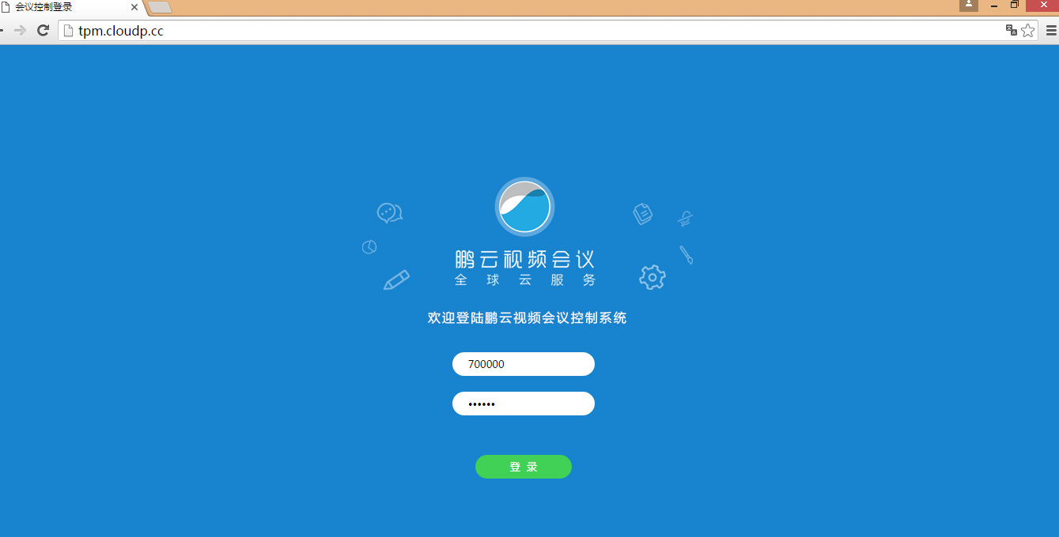

Video settings
Setting the screen display pattern, home screen display of some ongoing meeting.
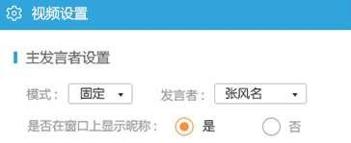
Main speaker’s setting: when setting pattern is “Fixed”, a speaker should be chosen. After setting up, the speaker will appear on the home screen (the big picture).
If the pattern is “Turning”, a speaker cannot be chosen. The attendee who speaks will appear on the home screen (the big picture).If there is a second speaker, this speaker will appear a few seconds later.
Display the nickname on the window or not: when “Yes” is chosen, the nickname of the attendee will be displayed on the home screen to show who is the speaker. When “No” is chosen, the nickname will not be displayed.

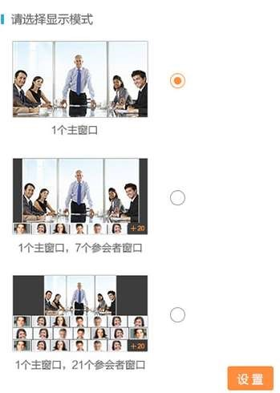

Choose display pattern
A. One main window: all the current attendees can only watch one main screen which is the screen of the current speaker or fixed speaker(the big picture).
B. One main window and seven attendees’ windows: all the current attendees can watch a big screen and seven small screens. If there are over 8 attendees, the display order of small screen will depend on the order of speaking.
C. One main window and 21 attendees’ windows: all current attendees can watch a big screen and 21 small screens arranged in three rows with seven small screens each row. If there are over 21 attendees, the display order of small screen will depend on the order of speaking.

Notice: when setting up “main speaker”, “nickname” or “display pattern”, clicking “Setting” is a must.

Attendees
It is used to manage all the attendees, such as clocking the meeting room, adding new attendees, closing all the microphone and hanging up on all attendees. It can also be used to close the video or voice of some attendee, or hang up on some attendee.
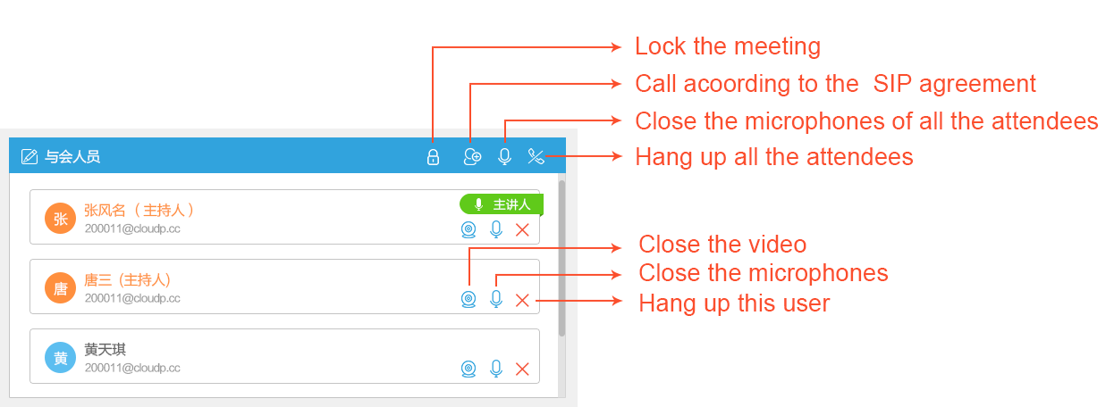

Waiting attendees
When the meeting room is clocked by the meeting controller, attendees who want to enter into the meeting room after the beginning will appear on this list. The meeting controller has the right to invite or reject him.

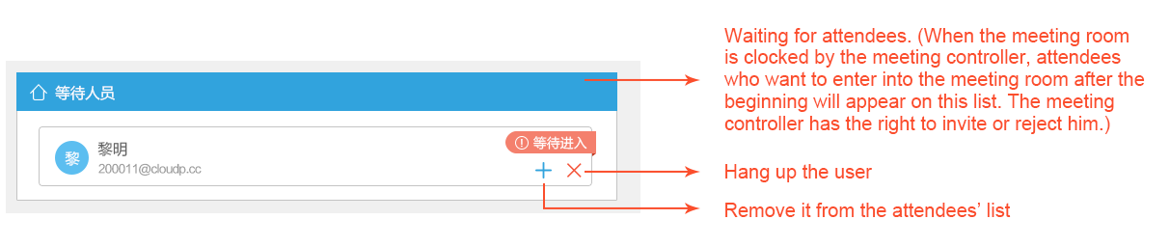

Communicating with typing words.
The meeting controller can communicate with attendees by texting words here.
