Operating Steps of Using the PC Browser of VConnect
First, log in.
- Link for VConnect Browser: meeting.cloudp.cc; or log in the product website: www.cloudp.cc and click “I want to have a meeting”on the right-top corner.
- Input meeting room number and name of the attendee to enter into the meeting.
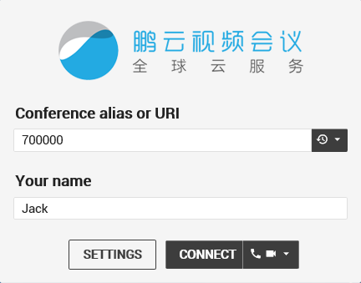
Note: options on the right side of the button “Connect” is used to choose whether open your computer microphone and camera or not before entering into the meeting room. Meanwhile, a choice can also be made according to the condition of your network. If the network is good, the microphone and camera can both be opened, and vice versa.
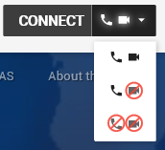
If there is password, please input it.

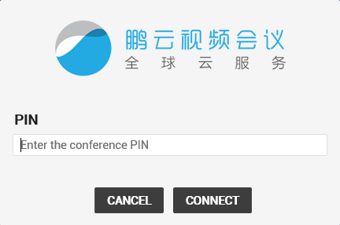
Note: if you are host, please input the host’s password to enter. if you are an attendee, please input the attendee’s password to enter.
3. “Settings” before attending the meeting.
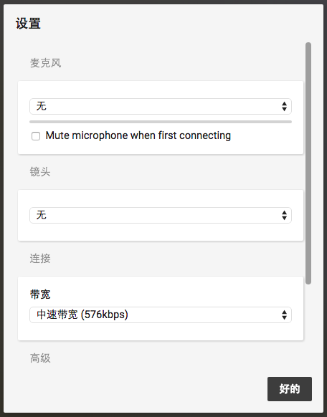

- Set up the microphone: set the state of the microphone (default means the default state of the system).
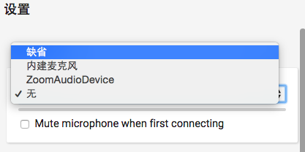
- Set up the camera: set the state of the camera (default means the default state of the system).
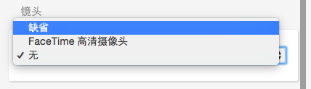
- Set up network connection: users can choose video picture definition matched the broadband according to the network condition (choose low speed broadband, the resolution ratio of the video is 360P, and choose top speed broadband, the resolution ratio can reach 720P).
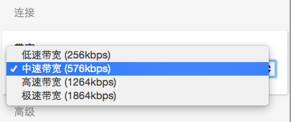

- Advanced settings
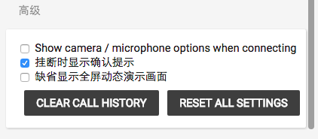
Second, enter into the meeting room
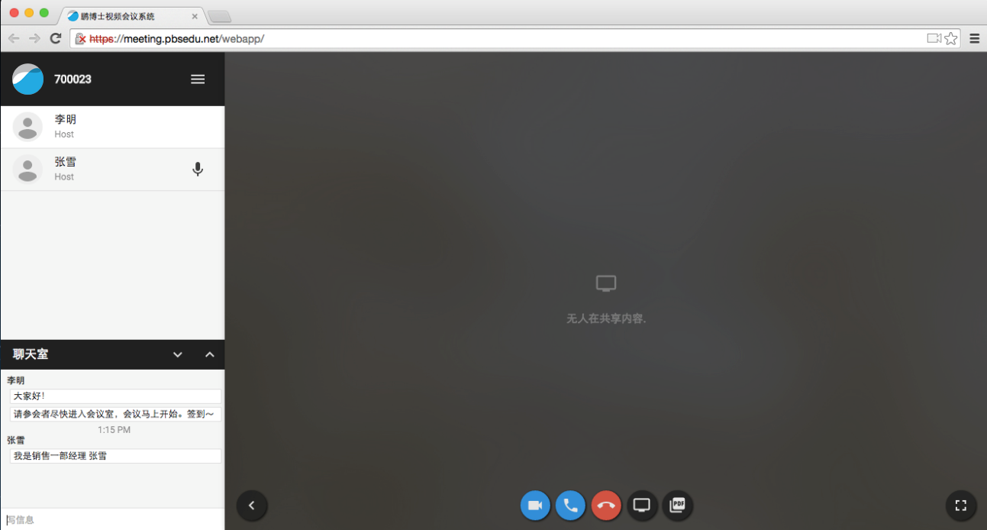

(Note: the meeting room number is on the left-top corner of the interface.)
- List of attendees
Display attendees’ names, state (mute or not), and authority (host or attendee).
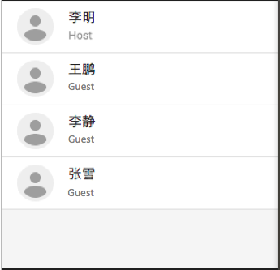 Mute：

- Chat room with words: interacting with all people by texting messages.
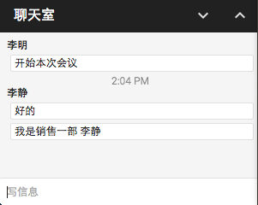

- Share video screen
Click: display local video screen, like this:
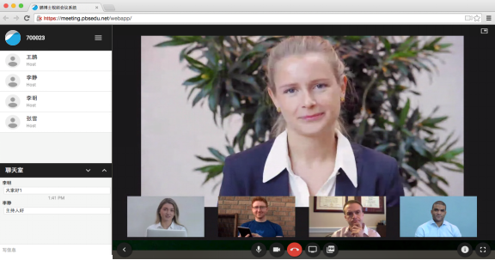

- Set microphone
Click: open local microphone and communicate by voice.
- Share files
Click: share pictures and PDF files quickly.
Click: share computer desktop, that is to say, share all the computer applications.

(Note: when using the sharing program of VConnect for the first time, a screen share plug-in needs to be installed. As is shown in the following picture, click “Install”, then it will exist until being uninstalled.)

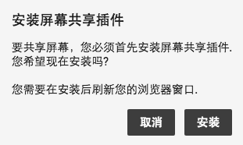
- Settings
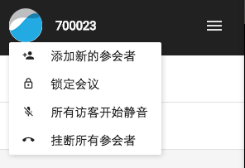
- : add new attendees, and choose the role of host or visitor, and the format of protocols;
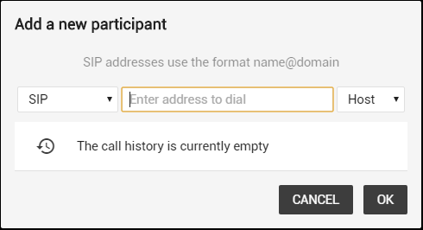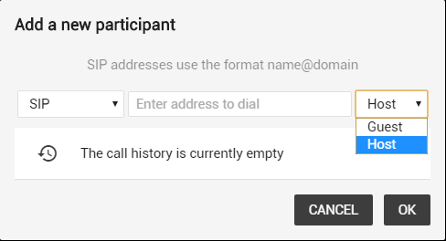
- : clock meeting, which means others who do not enter the meeting room cannot enter when the meeting is clocked;
- : close microphones of all attendees;
- : hang up on all attendees.
7. Disciplines in the meeting
- Host should close the microphones of all the attendees after entering into the meeting room.
- Attendees should close their microphones after entering into the meeting room. Open it when speaking.
- In order to experience the video conference better and avoid noise, echo, and noise caused by other devices, a suggestion will be given: all the attendees should use external headset and microphone, and close the microphone after entering into the meeting room, and open it when speaking.

