Installation Instructions for Local Plug-ins in Google Chrome Browser

1/7
By extending programmed plug-ins, the function of browser can be more powerful. Though the function may not be used by general users, it is still necessary to know something about it. Some useful plug-ins can be used someday.

2/7
First, open our chrome browser, and then click the Tools icon on the menu at the right-top corner.
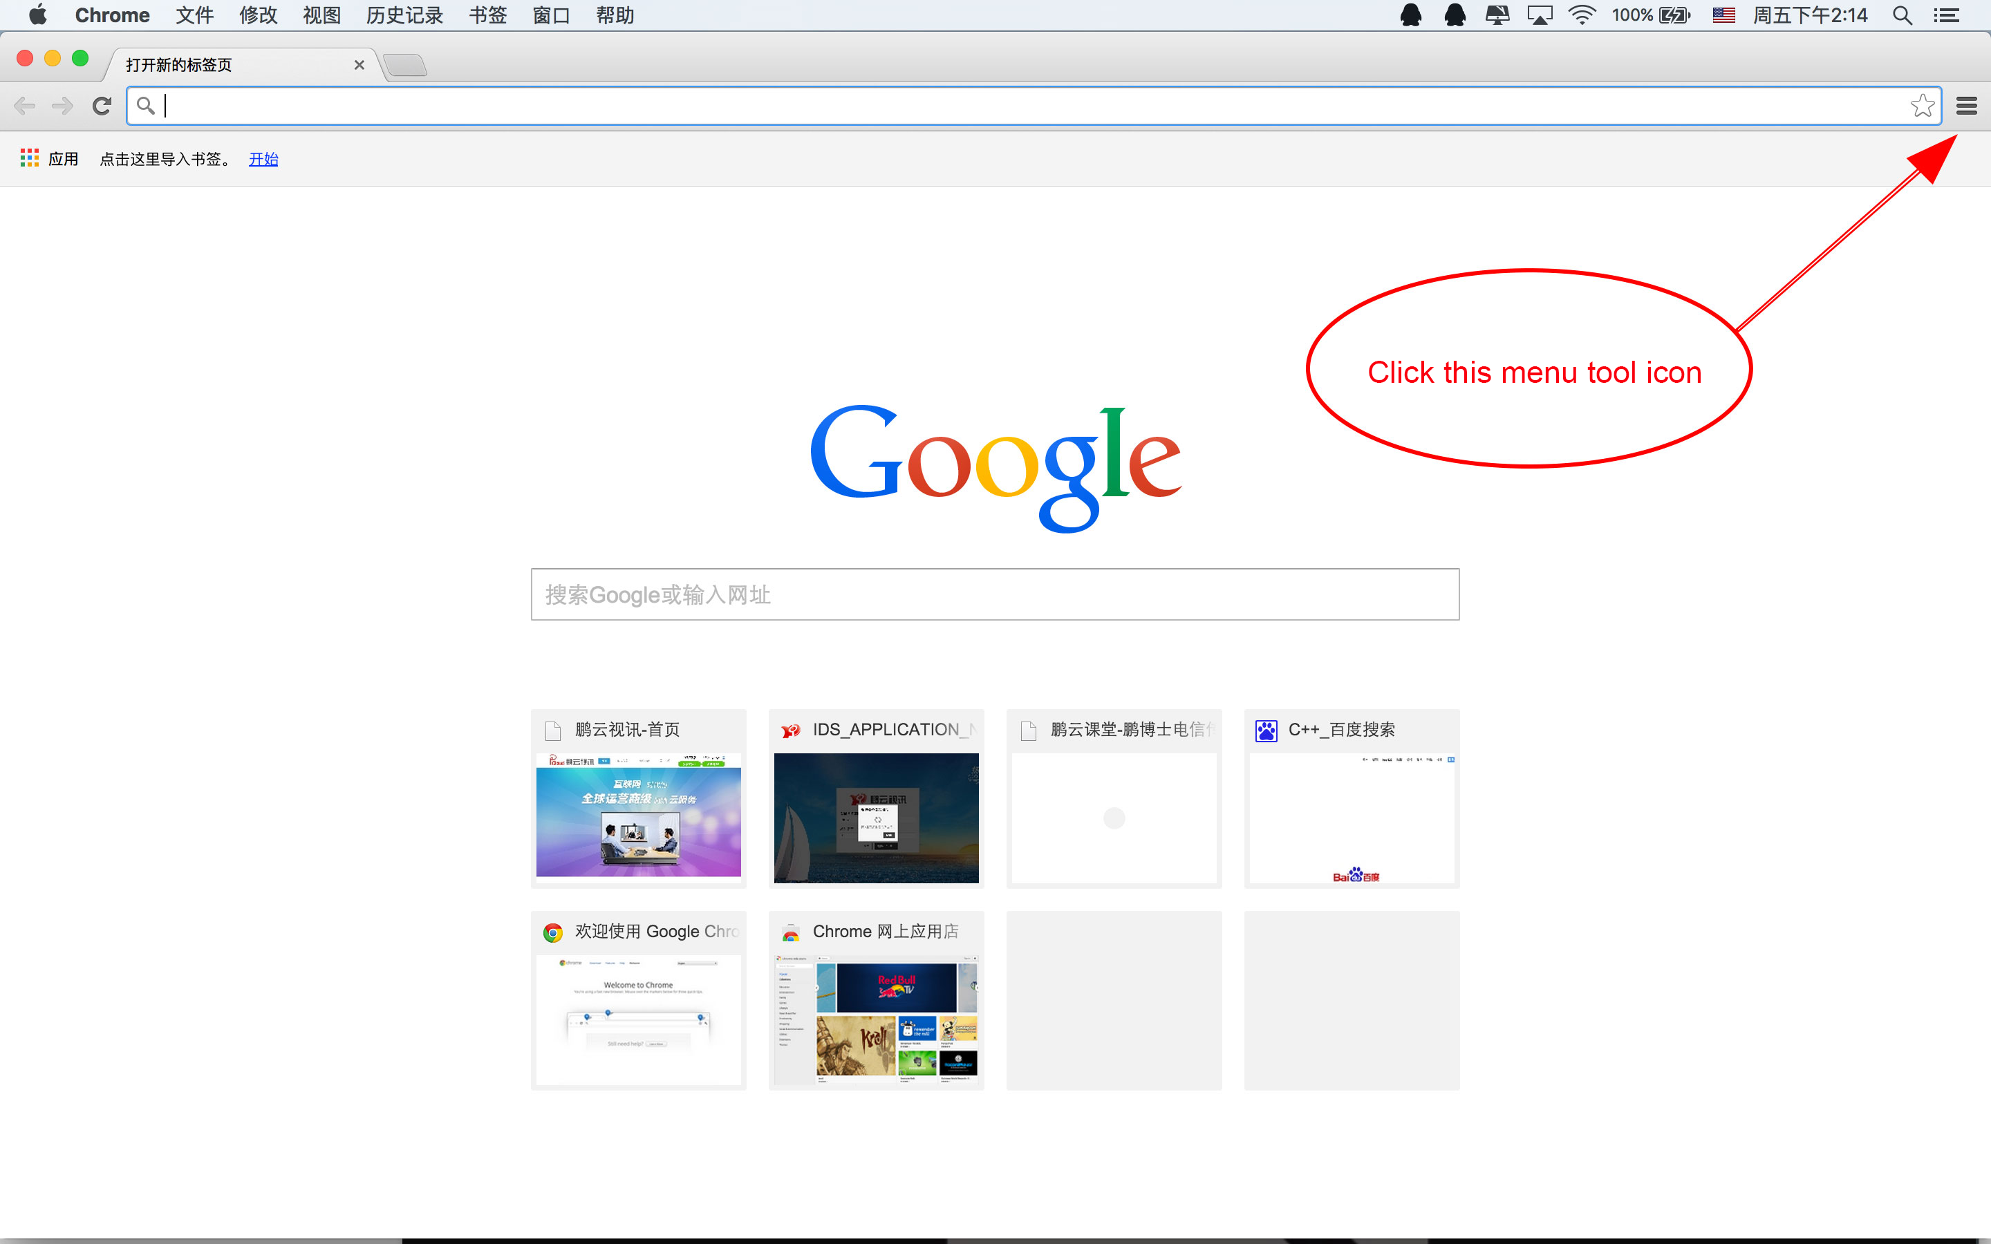

3/7
Second, in the pop-up menu, choose “More Tools”, and then choose “Extension”. The management interface of plug-ins will be opened.
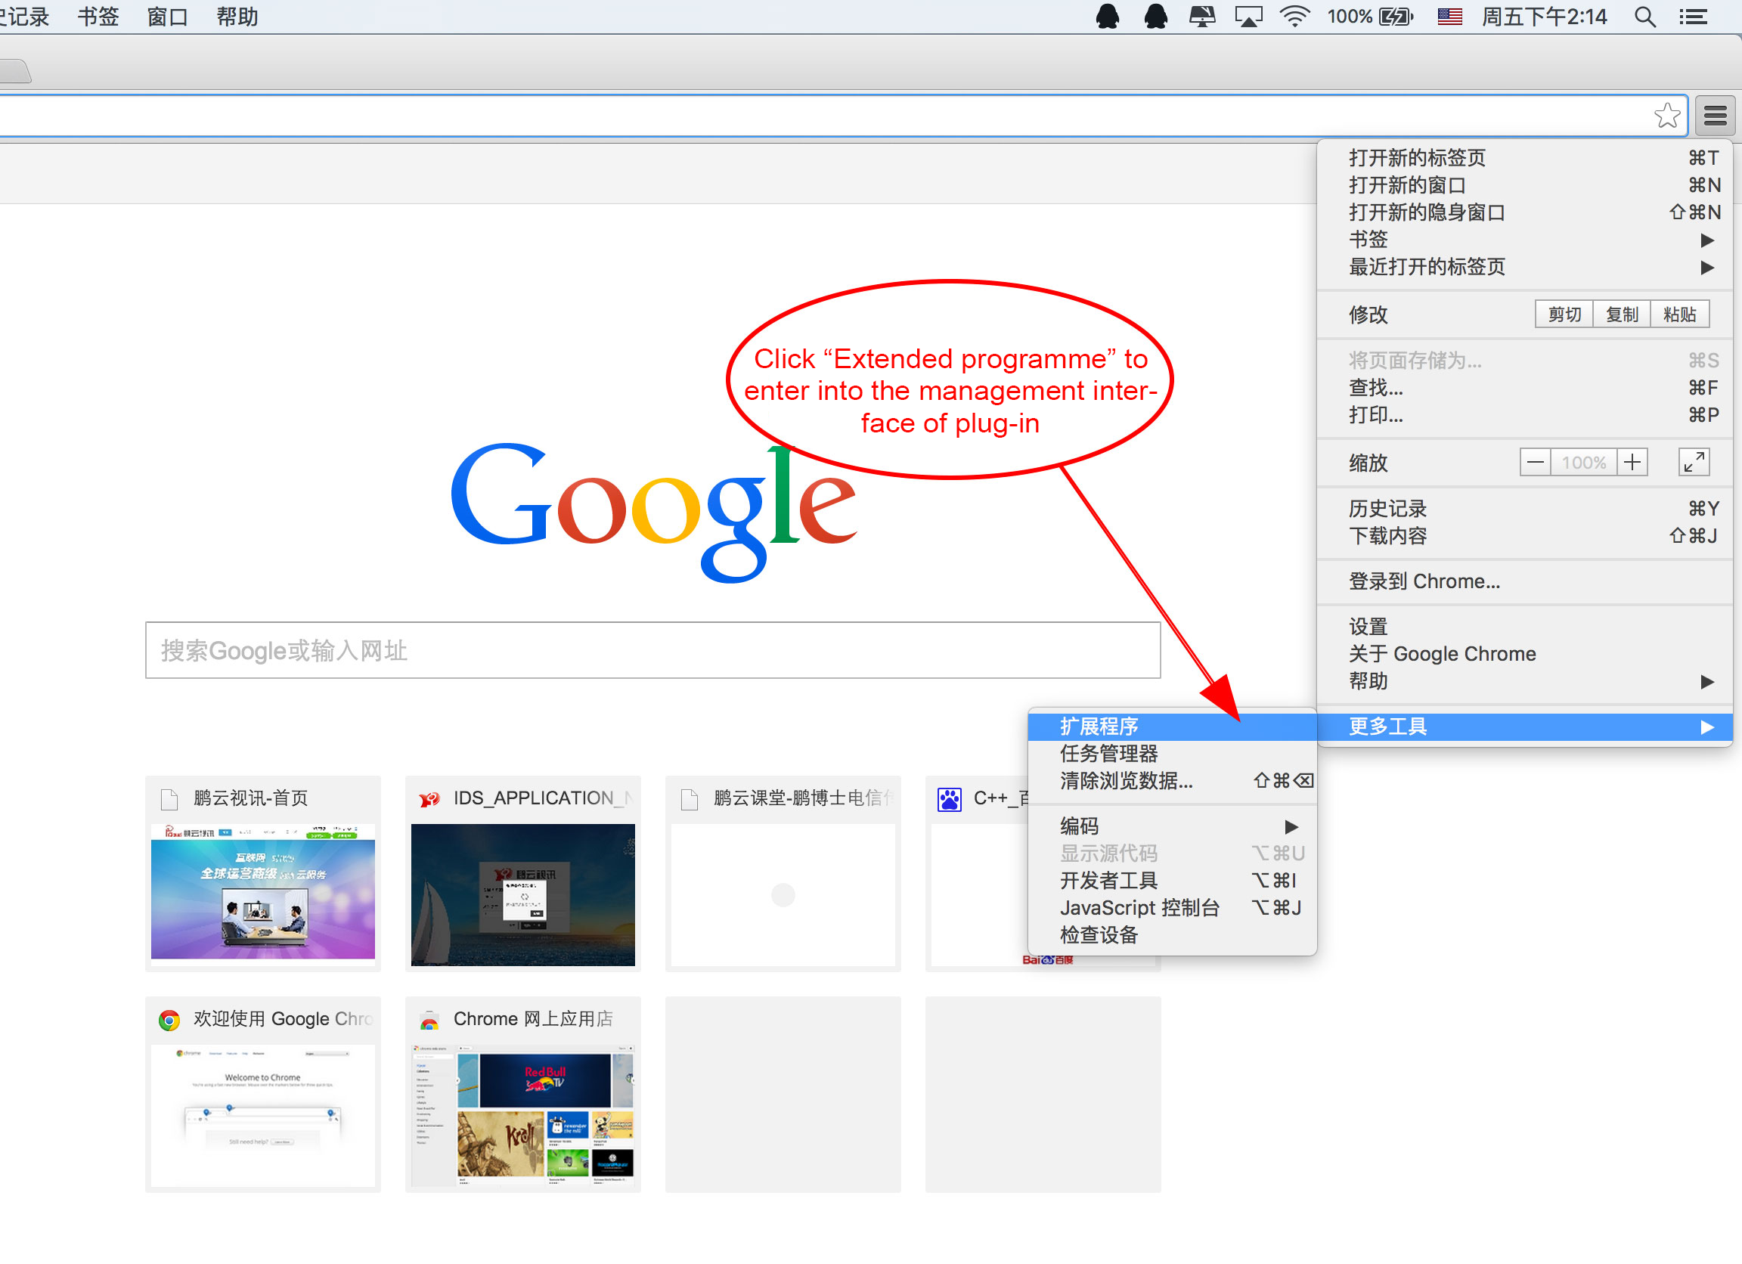

4/7
Third, drag the downloaded plug-in program into this interface.
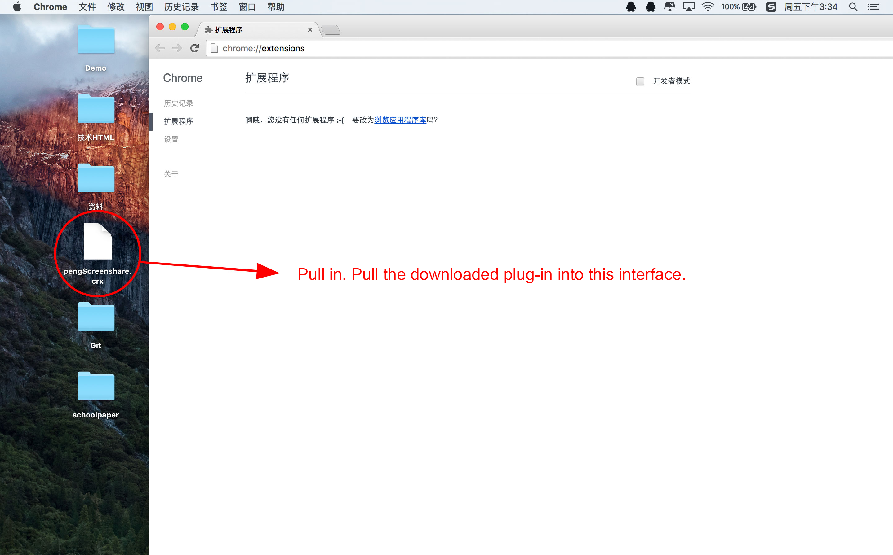

5/7
Fourth, confirm to add the extension program or not. Of course, choose “Add”, and click “Add”.
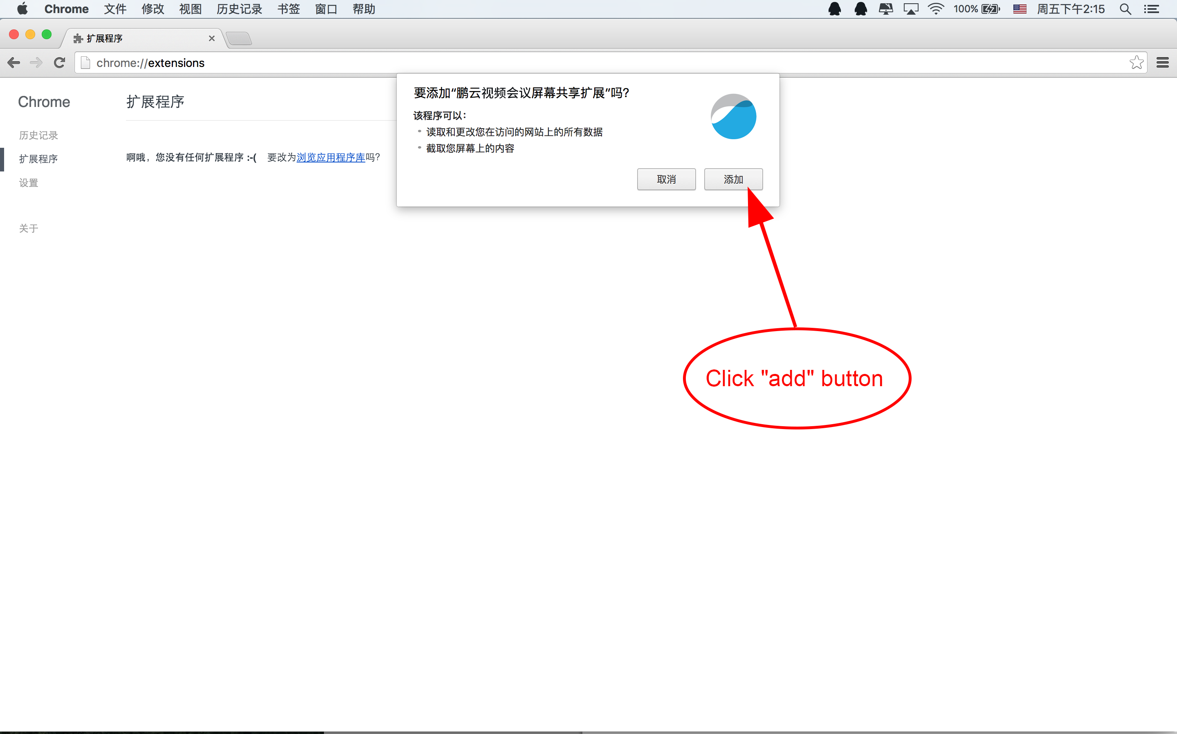

6/7
Fifth, now the extension program has been installed, and then choose “Enabled”
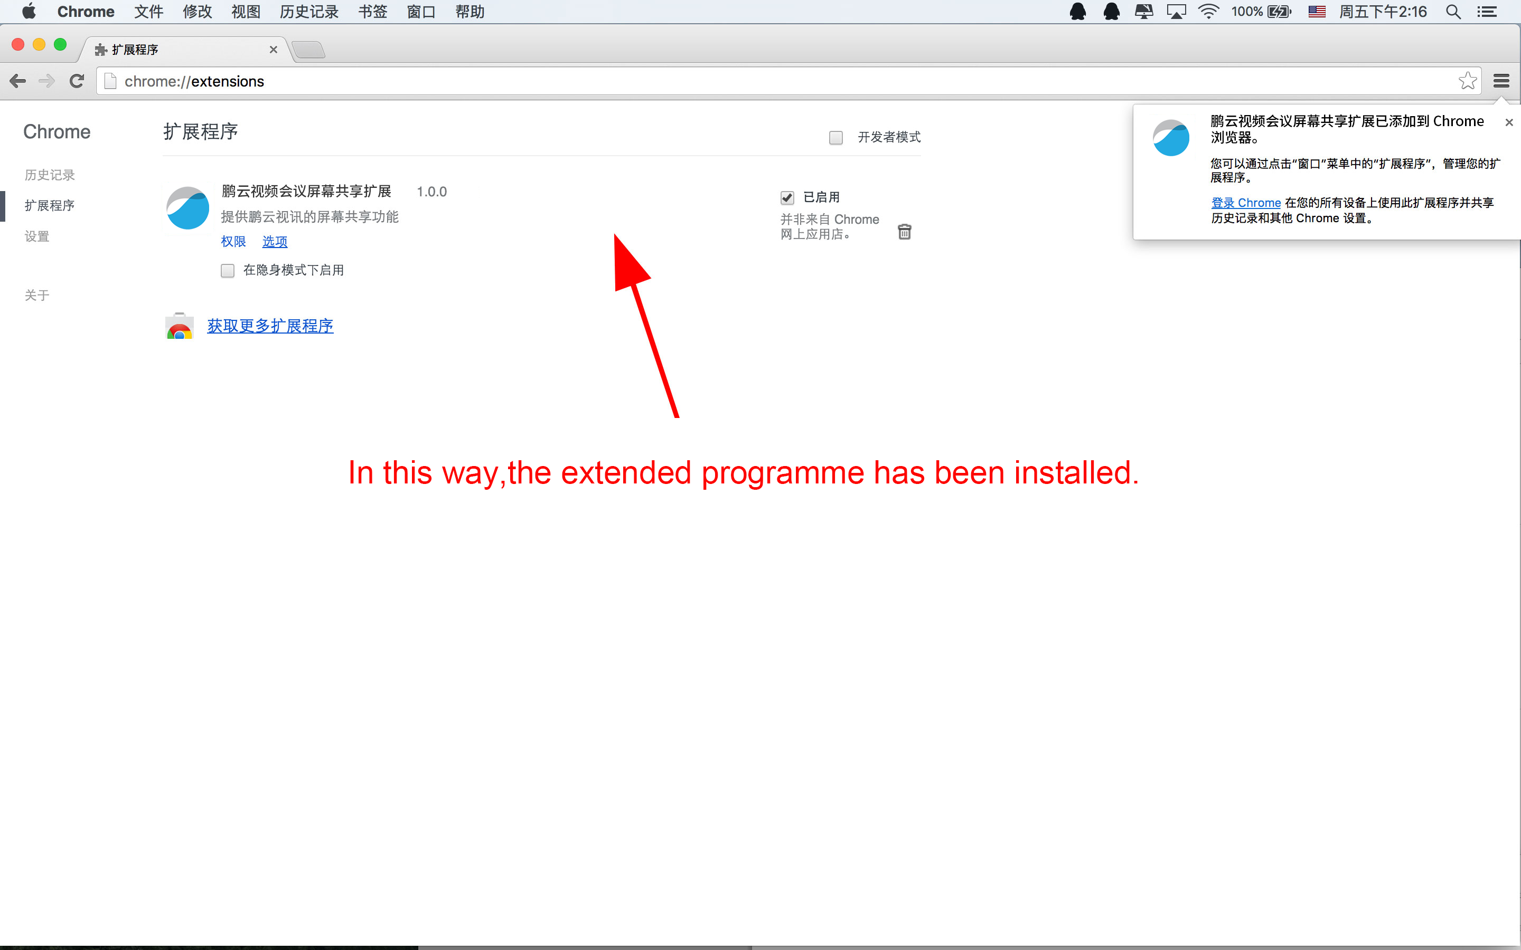

7/7
Sixth, restart the browser, and the desktop share feature of VConnect can be used.

