**Instructions for Mobile Terminal of VConnect — Android/iOS**

**First, download APP in iPhone**

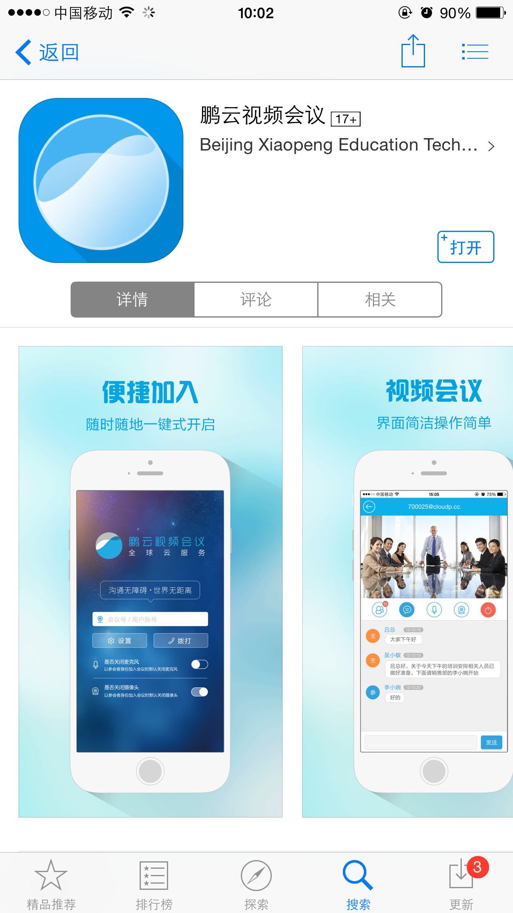

Method one: open the App Store, and search “VConnect”, and download and install it.

Method two: log in the website: [www.cloudp.cc](http://www.cloudp.cc), click “Materials Downloaded”, click “Mobile Phone Client Download”, and then scan the QR code.



After scanning the QR code, open the interface on the right side in the browser and choose iOS version and click download.

**Second, download APP in Android**

1. Log in the website: [www.cloudp.cc](http://www.cloudp.cc), click “materials downloaded”, click “Mobile Phone Client Download”, and then scan the QR code and install it.



1. When installing VConnect of Android version, the function of scanning QR code should be used first. Scan the QR code and install the program. After scanning, the phone will redirect to the following page:

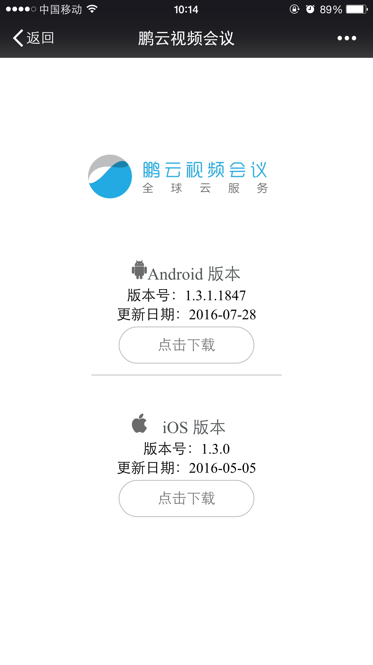

Click “Download”, and install it according to the notes. After installing it, click Open” and use it.

## dengluEntering into VConnect

1. Setting up nickname: entering into the home page, click the “Settings” button: 未标题-1 to enter into the page to set up nickname. Then click “save”.

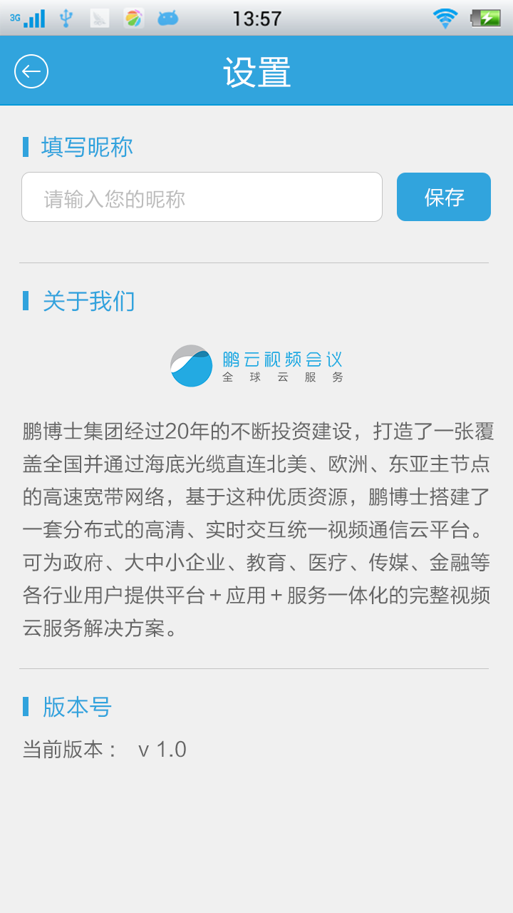

1. Setting up the pattern of microphone or video when entering into a meeting: on the logging page of VConnect, whether closing the microphone or video or not can be chosen.

**Notice: The default is “close the microphone when entering the meeting as an attendee”. It can be changed according to personal habits.**

1. Input login account: please input meeting number or account in this boxadsfdasf.

Notice: if the nickname is not set up, after inputting meeting number or account, the nickname should be input like Picture A, then click “save”.

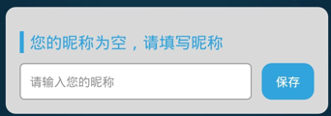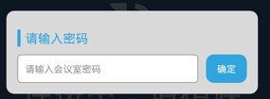If the meeting room has a password, the password should be input like Picture B.

图A-输入昵称 图B-输入密码

1. When the above settings are finished, then clickadsfadf  to enter into the meeting.

Notice: after entering into the meeting successfully, please choose “Allow” when the functions of “taking pictures, recording or flashlight”, and “communication record or local record” are reminded. If the local video or voice doesn’t work, please find “Settings of Applications” in the mobile phone and allow the use of “microphone and camera” in our application.

1. Entering into meeting system



1. The above picture is the screen after entering. The screen on the left-top corner shows the user. Clickingadfadfcan hide your own screen, and then the button will be like 未标题-1. If you want to display your screen, click it again.
2. indicates the state of the front camera. Click it to open back cameraor close the camera.
3. indicates the state of voice. Click it to close voice.
4. indicates the attendees. The number on itindicates the number of attendees in current meeting. Click it and the interface of personnel management will pop up.

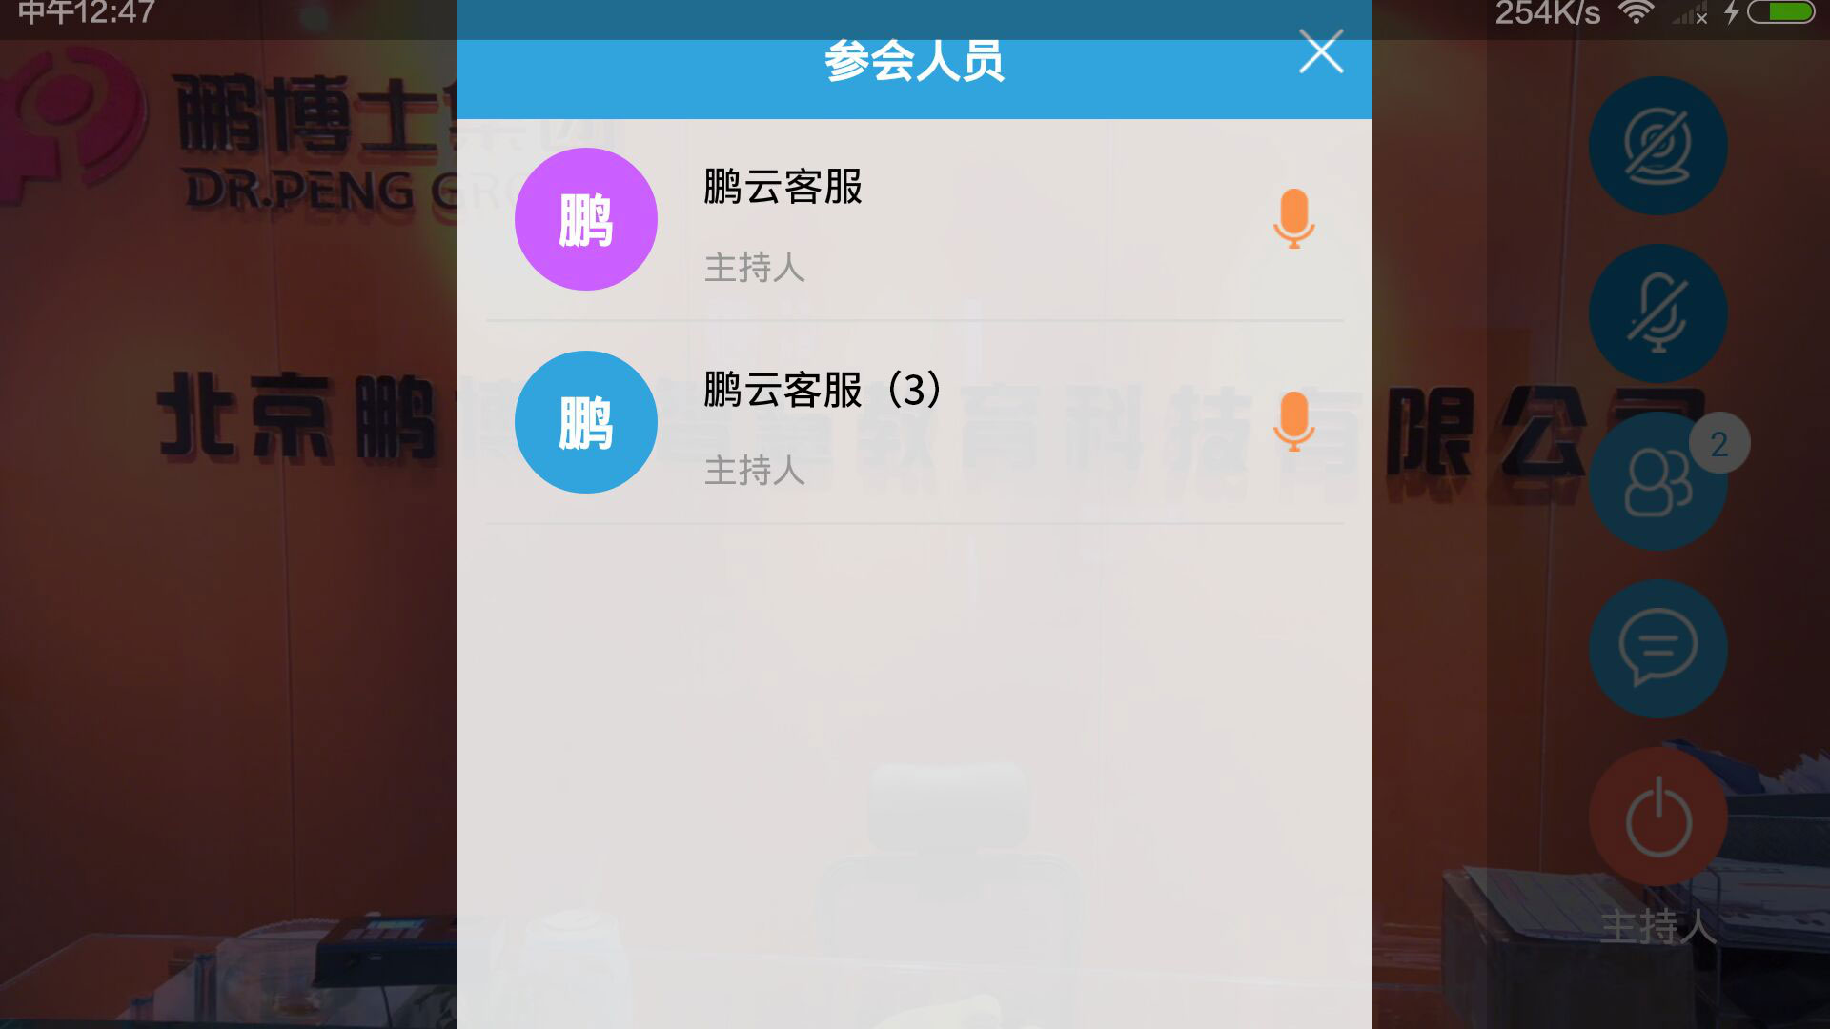

1. If an attendee enters the meeting as “host”, he can manage all the attendees on this page. For example, clickingadfdsafdasf will close all microphones.
2. is the button of choosing text communication. When numbers appear on it, it indicates the number of unread information. Click this button, the following page will pop up, and the words can be read.

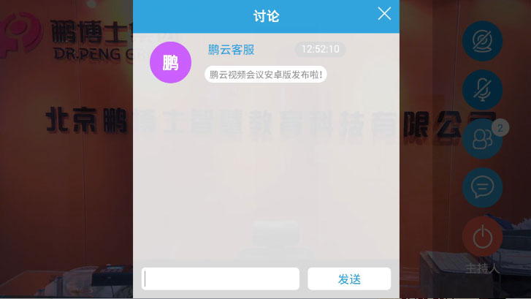

1.  is the button to end the meeting. Click it to end and exit from the meeting.

Notice: under , your role in the meeting is displayed, such as “attendee” or “host”.