Instructions for PC Client of VConnect — Windows Operating System
First, download
- Download the PC client of VConnect: log in www.cloud.cc, and then click “Windows System Desktop” in the “Materials Downloaded” on the top of this page to download and install the client.
Second, register and use
- Start page
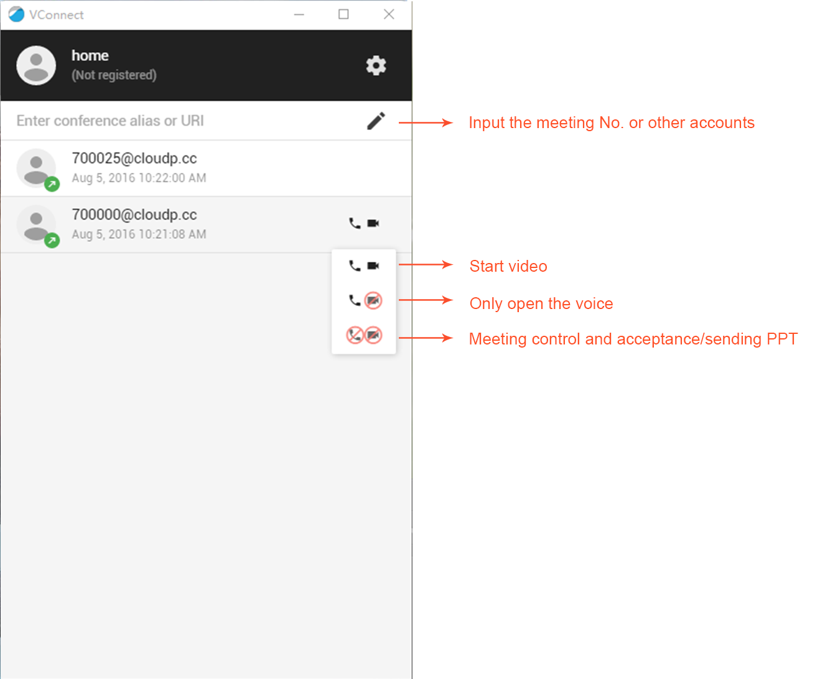

- Configuration page
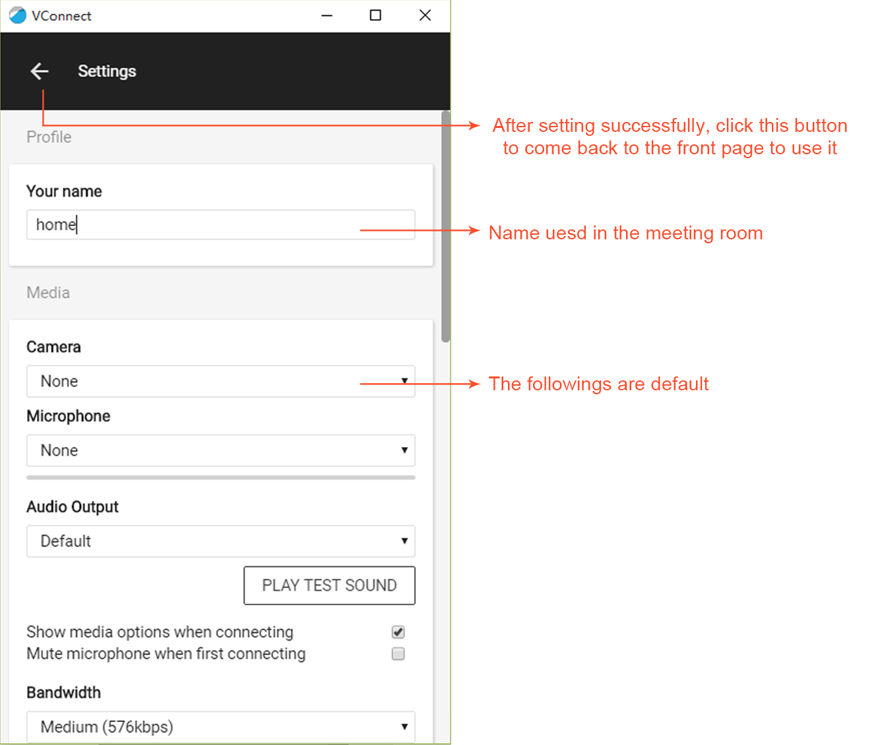
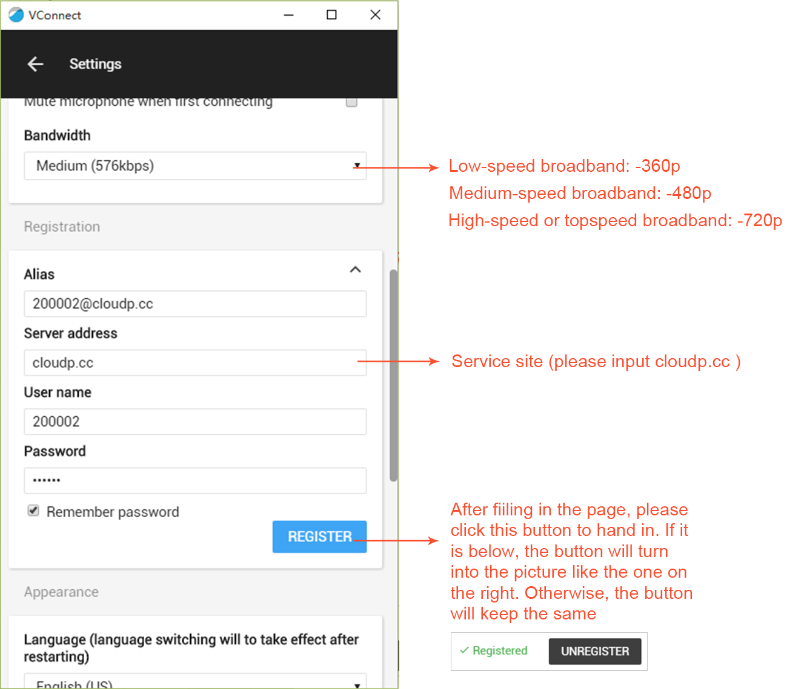

Note: please use the formal account that has been opened up for you as the registration alias. 200002 is not effective.

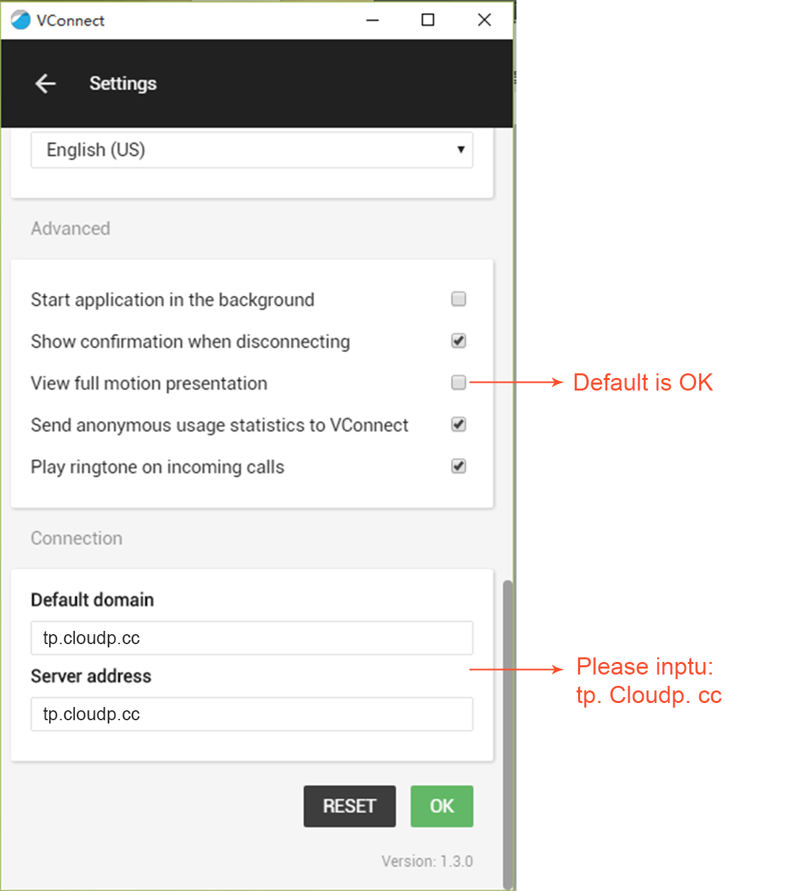

- After calling the meeting room or equipment, the interface will be like this:

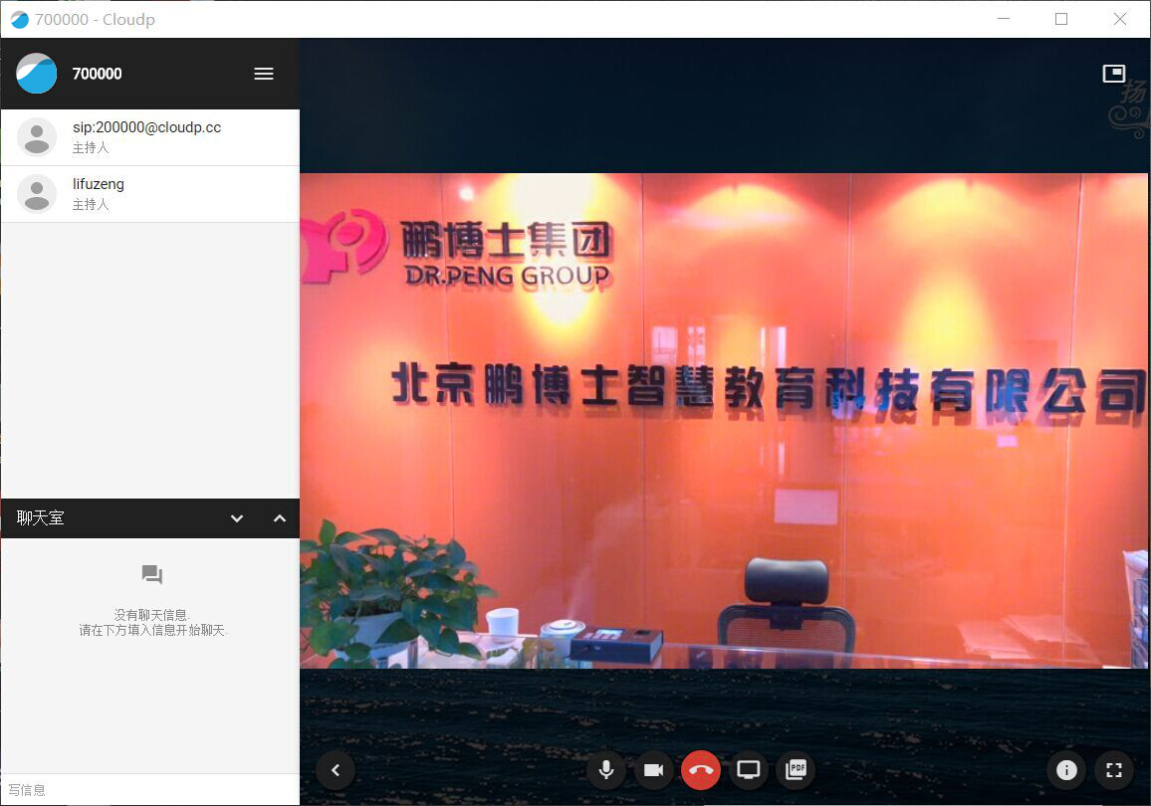
Note: PC client can still use the function of “share desktop” without installing the plug-in.
- List of attendees

Display attendees’ names, state (mute or not), and authority (host or attendee).

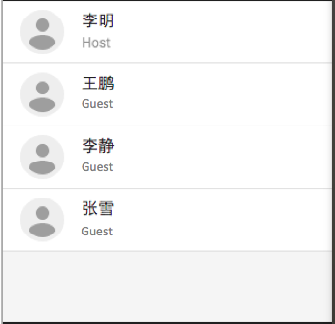 静音：

- Chat room with words: interacting with all people by texting messages.

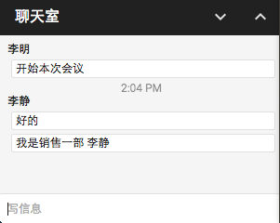

- Share video screen
Click: display local video screen, like this:
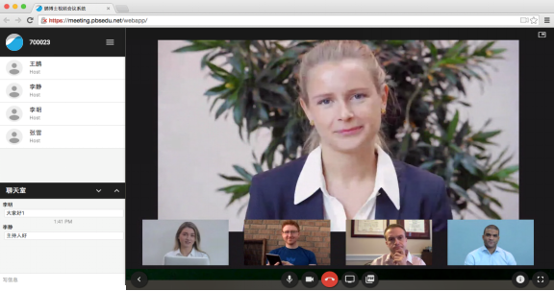

- Set microphone
Click: open local microphone and communicate by voice.

- Share files
Click: share pictures and PDF files quickly.
Click: share computer desktop, that is to say, share all the computer applications.
(Note: when using the share program of VConnect for the first time, a screen share plug-in needs to be installed. As is shown in the following picture, click “Install”, then it will exist until being uninstalled.)

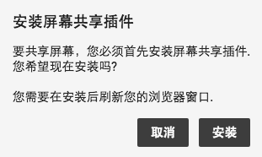

- Set
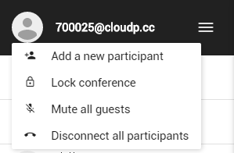
- : add new attendees, and choose the role as host or visitor, and choose the format of protocols;
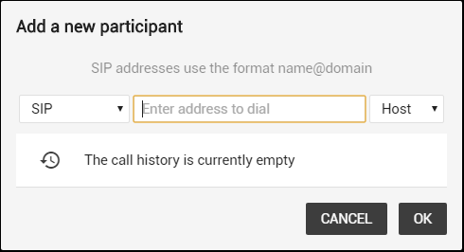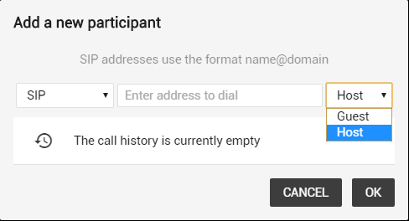
- : clock meeting, which means others who do not enter the meeting room cannot enter when the meeting is clocked;
- : close the microphones of all attendees
- : hang up on all attendees.

